***GIT***

Why use Version (Source) Control Systems:-

A version control system (often called a source code control system) does these things:

♦Keeps multiple (older and newer) versions of everything (not just source code)

♦Requests comments regarding every change

♦Allows “check in” and “check out” of files so you know which files someone else is working on

♦Displays differences between version

Benefits of version control:-

For working by yourself:

♦Gives you a “time machine” for going back to earlier versions

♦Gives you great support for different versions (standalone, web app, etc.) of the same basic project

For working with others:

♦Greatly simplifies concurrent work, merging changes

What are Git and GitHub :-

♦Git is a free and open source distributed version control system designed to handle everything from small to very large projects with speed and efficiency

♦ GitHub is a web-based Git repository hosting service, which offers all of the distributed revision control and source code management (SCM) functionality of Git as well as adding its own features.

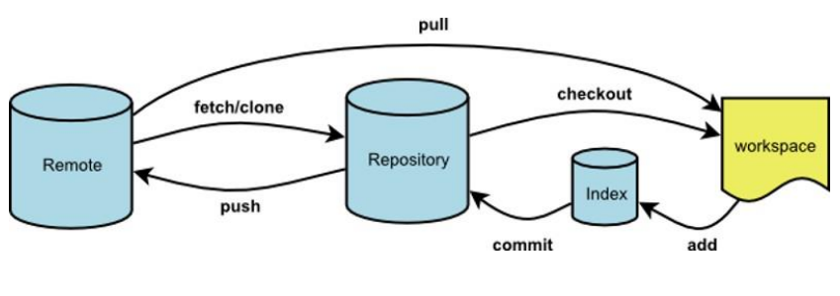

BASIC GIT COMMANDS :-

git status // to show file is committed or not

git commit –m “ To commit files”

git reset –hard //to partially remove changes

git pull //to add file in main

git checkout –b Branch name // add branch

git branch // see list of all the branch

git diff // see diff between the committed code and non committed code

git clone Http/SHP link // to copy someone else repo

git add. // add the changes to the file to repo

Git add –u // add those changes which we made by our own

Git push origin master // to push the file in the repo

Git cherrypick –m1 commit id // to particularly add a particular set of code

need help: https://help.github.com